ITE 400 SYSTEM INTEGRATION DT-fied PROJECT DOCUMENTATION

1. EMPATHY

- Method card used: **Analogous Empathy**

*Students explore other dynamic websites or related platforms to gather insights and inspiration, analyzing what works well and what could be improved.*

**EXPECTED OUTPUT**: Analogous Inspiration Findings

*A list of best practices and interesting features from other dynamic websites that could inspire your design.*

2 .DEFINE

-3 POV Statements: Clear statements that encapsulate user challenges and needs.

1.Hotel administrators need an efficient way to manage room reservations and guest information because outdated systems cause delays and errors in bookings, leading to customer dissatisfaction

2Guests need a seamless and intuitive booking process because unclear availability, complex forms, and slow response times make it difficult to secure a room quickly and confidently."

3Returning guests need a personalized experience with saved preferences and quick access to past bookings because manually entering details every time feels repetitive and frustrating

3. IDEATE

-Idea List: A diverse set of ideas for different elements like content organization, and user engagement and then let students categorize.

-ntroduce an AI-powered chatbot to assist users with FAQs and booking queries

-Create a guest review and rating system for transparency

4. PROTOTYPE

-For IT, Wireframes: Initial layouts - primary website components.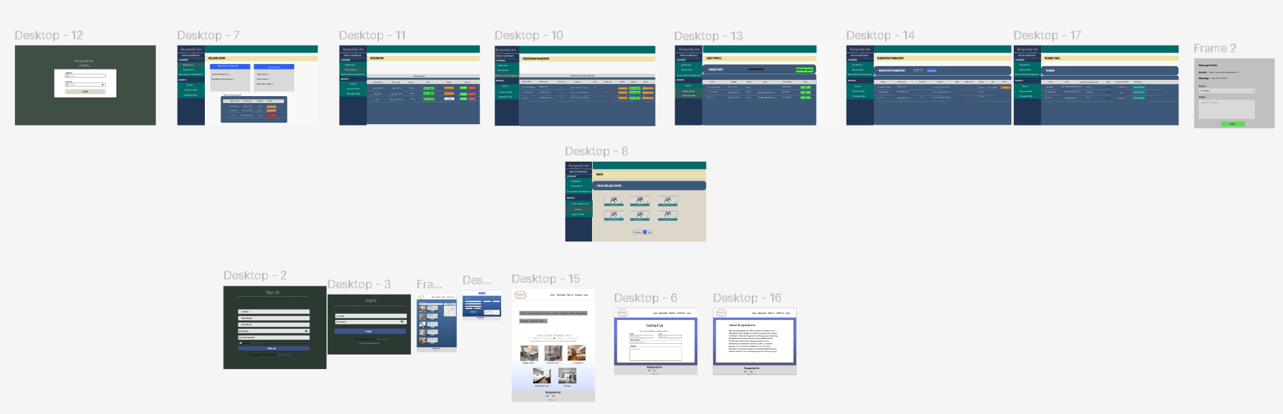

5. TEST

-User Testing Observations: Notes on user interactions, highlighting any challenges or preferences observed.  
-Users found the **m**enu layout intuitive, but some struggled to locate advanced filters.

# **EMPATHY Analogous Inspiration Findings**

### **1. Project Overview**

* **Project Name:** burgundy Reservation System A smart and efficient Reservation splutin
* **Objective:** online reservation list hassiel
* **Target Users:** admin and user

### **2. Industry Comparisons**

*(Identify industries/websites with similar features and how they relate to your project.)*

| ***Industry/Website*** | ***Key Features*** | ***Relevance*** |
| --- | --- | --- |
| *Example: E-commerce platforms* | *Shopping cart, product filtering, user reviews* | *Needed for online shopping functionality* |
| *Reservation platform* | *reserve* | *Need for reservation foctionality* |
|  |  |  |

### **3. UI/UX Inspirations**

* **Color Scheme & Typography:** blue ,white and green
* **Navigation & User Flow:** home,reservation ,about us,contact us,log in, dashbord
* **Interactive Elements:** buttons

### **4. Functional Features to Adopt**

* User experience
* interactive

### **5. Key Takeaways**

* **Best Practices to Implement:** mplement search functionality with filters for quick access.
* **Unique Features to Consid:er**Real-Time Availability & Price Updates
* **Next Steps:** Deploy on a reliable hosting platform

**DEFINE**

**Point-of-view**

*Create POV statements that define the user’s primary challenges and goals regarding information management on dynamic websites.*

1.**Challenge:**

The admin struggles to **efficiently manage and update reservations** in real time, leading to **double bookings** and **delays in guest check-ins**.

**Goal:**

They need a **centralized and dynamic dashboard** that provides **real-time booking updates**, **automated conflict resolution**, and **easy data retrieval** to streamline hotel operations.

2.**Challenge:**

Guests find it difficult to access **accurate, up-to-date room availability and pricing**, often leading to confusion or frustration when they attempt to book.

**Goal:**

They need a **seamless and intuitive reservation system** that displays **real-time availability, dynamic pricing, and instant confirmation** to ensure a **smooth booking experience**.

3.**Challenge:**

The IT manager faces **security risks** such as **unauthorized access**, **SQL injection**, and **data breaches**, putting both guest and admin information at risk.

**Goal:**

They need a **secure, role-based access system** with **encrypted connections, automated backups, and vulnerability monitoring** to **protect sensitive data and maintain system integrity**.

**How-Might-We**

*Formulate HMW questions to frame the design challenges clearly, such as "How might we make information easily accessible on a dynamic website?"*

1.This ensures that admins can efficiently manage reservations, track room availability, and avoid conflicts.

2.This ensures that admins can efficiently manage reservations, track room availability, and avoid conflicts.

3.This ensures that admins can efficiently manage reservations, track room availability, and avoid conflicts.

**IDEATE**

*A diverse set of ideas for different elements like content organization, and user engagement and then let students categorize.*

IDEA LIST

1. Content organization:  
   A sticky sidebar with links to "Reservations," "Guest Profiles," and "Reports" in an admin dashboard.
2. User Engagement

Reward users with badges or milestones for completing tasks efficiently.

1. Navigation & accessibility:

nsure a seamless experience across devices with adaptive layouts.

1. Personalization & User Experience  
   Allow users to personalize their dashboard with drag-and-drop widgets
2. Visual & Interactive design  
   Add subtle animations for button clicks, hover effects**, and loading states** to enhance engagement.

**PROTOTYPE**

* *Mock up FIGMA LINK with QR CODE for easy access,*
* *Attach here your mock up from figma PER NAVIGATION*
* *https://l.facebook.com/l.php?u=https%3A%2F%2Fwww.figma.com%2Fdesign%2F3de0edWGVEqmcsjBehsAwE%2FUntitled%3Fnode-id%3D0-1%26t%3DCmvwbRA18HOf6Izd-1%26fbclid%3DIwZXh0bgNhZW0CMTAAAR0SJYlH3mQNpPc481zOg4aZdiz5DUooIH_7dTivKYQapE0VR-Sadv4EI4A_aem_yAWttk5ZxVg2aKQJhGSDgg&h=AT0_uIhiN0KjAIJDxfxmwO-4dcrT6U_Wupcwp9cAcoX9LxWFXwJUKHPsRK66nu9uZNjzy-k6NbT8-b4SkI-3Q9kH7pCu1DfgUF981o6_d0pomf_B12jQt0SV1bb6J0HeWA0ZTiSKTK2EwCX57sJaIg*

**TEST**

User Testing Observations:

Tested by: admin

Tester role: dev

Device & Browser used: laptop/visual

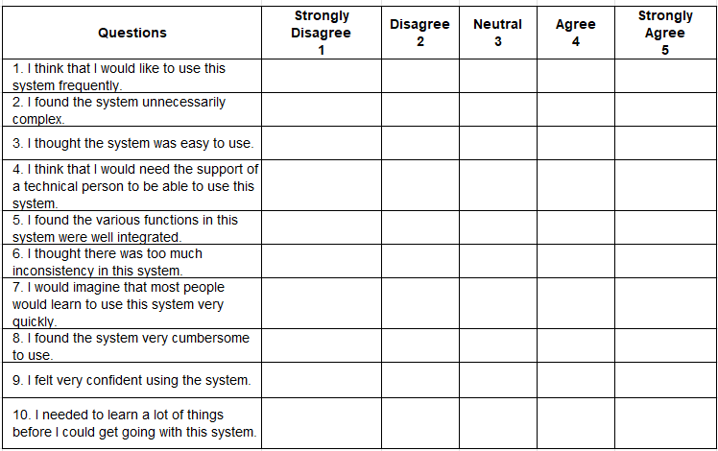

If you have 2 or more users in your system, you are required to look for 5 participants to evaluate the usability of your system per type of users. But if you only have 1 type of user, please require 10 participants in total. Please be careful of selecting participants, they must understand what is the system all about. You may ask 3RD YEAR STUDENTS to evaluate your system.

**NEXT, calculate and interpret your score , Please follow below:**

## How to Calculate Your Usability Score using SUS

Here is an overview of the method used in finding your SUS score.

Your users will have ranked each of the 10 templates questions above from 1 to 5, based on their level of agreement.

* For each of the odd numbered questions, subtract 1 from the score.
* For each of the even numbered questions, subtract their value from 5.
* Take these new values which you have found, and add up the total score. Then multiply this by 2.5.

The result of all these tricky calculations is that you now have your score out of 100. This is NOT a percentage, but it is a clear way of seeing your score.

## What Your SUS Score Means Compared to Industry Standards

The System Usability Scale is not diagnostic and will not tell you what specific problems you face, but it will give you a red or green light to know how badly your usability needs work.

The [average System Usability Scale score is 68](http://www.measuringu.com/sus.php). If your score is under 68, then there are probably serious problems with your website usability which you should address. If your score is above 68, then you can relax a little bit.

Here’s an overview of how your scores should measure:

* 80.3 or higher is an A. People love your site and will recommend it to their friends
* 68 or thereabouts gets you a C. You are doing OK but could improve
* 51 or under gets you a big fat F. Make usability your priority now and fix this fast.

#### 